**CHAPTER 1**

**THE STUDY AND ITS PROBLEMS**

**A. BACKGROUND OF THE STUDY**

To recognize an individual, we often use facial features as our references and, over the past few decades, using the same method, similar recognition techniques have been able to recognize automatically an individual. Simple geometric models were used by the early face recognition algorithms, but the recognition process has now matured into a science of sophisticated mathematical representations and matching processes. Face recognition can be used for both verification and identification.

The study of biometrics in the last three decades has greatly improved and the application of this concept has been widely used in different ways particularly for security and important social purposes. Therefore, identification and validation procedures have developed into main technology in numerous areas, such as entrance control and access control.

One form of biometric solutions is what we called face recognition. Face recognition is an integral part of biometrics. In biometrics basic traits of human is matched to the existing data and depending on result of matching identiﬁcation of a human being is traced. Facial features are extracted and implemented through algorithms which are eﬃcient and some modiﬁcations are done to improve the existing algorithm models. Computers that detect and recognize faces could be applied to a wide variety of practical applications including criminal identiﬁcation, security systems, identity veriﬁcation etc. Face detection and recognition is used in many places nowadays, in websites hosting images and social networking sites. Face recognition and detection can be achieved using technologies, methodologies and algorithms that are related to computer science.

Within last several years, there are several face recognition algorithms written by researchers. One of which is the *Eigenface* algorithm. The main idea of *Eigenface* is to get the features in mathematical sense as an alternative to physical face feature by using mathematical transform for recognition. There are two phases for face recognition using *Eigenface*. The first phase is the training phase. In this phase, a large group of individual faces is acted as the training set. These training images should be a good representation of all the faces that one might encounter. The size, orientation and light intensity should be standardized. For example, all images are of size 50 x 50 pixels and all are frontal faces. Each of the images in the training set is represented by a vector of size N by N, with N representing the size of the image. With the training images, a set of eigenvectors is found by using Principal Component Analysis (PCA). The basic idea of PCA is to take advantages of the redundancy existing in the training set for representing the set in a more compact way.

**B. EXISTING ALGORITHM**

**Principal Component Analysis based Eigenface Algorithm**

Algorithm features of the face image are extracted using Principal Component Analysis (PCA). PCA is dimensionality reduction method which retain majority of the variations present in the data set. Eigenface is the simplest approach to PCA. Eigenface gets the facial features in mathematical sense as an alternative to physical face feature by using mathematical transform for recognition as shown in Figure 1.

Read the colored image and convert it into gray scale image

Get the image data in form of a matrix

Normalize each input face image by subtracting the mean face

Calculate covariance matrix

Calculate the eigenvalues of the covariance matrix and keep only k largest eigenvalues

Compute the eigenvectors of covariance matrix

Compute eigenfaces containing highest information of face images

Compute the projected image

Calculate the mean

*Figure 1: Basic Architecture of Eigenface using PCA*

**C. STATEMENT OF PROBLEMS**

**1.) Sensitivity to illumination cause inaccurate or inability to recognize a person.**

The only input accepted by the Eigenface algorithm using PCA is a single N by N image. The single image accepted by the system will be used for face recognition by converting it into a matrix. Since the eigenface representation is, in a least-squared sense, faithful to the original images, its recognition rate decreases for recognition under varying illumination.

*Sample Result:*

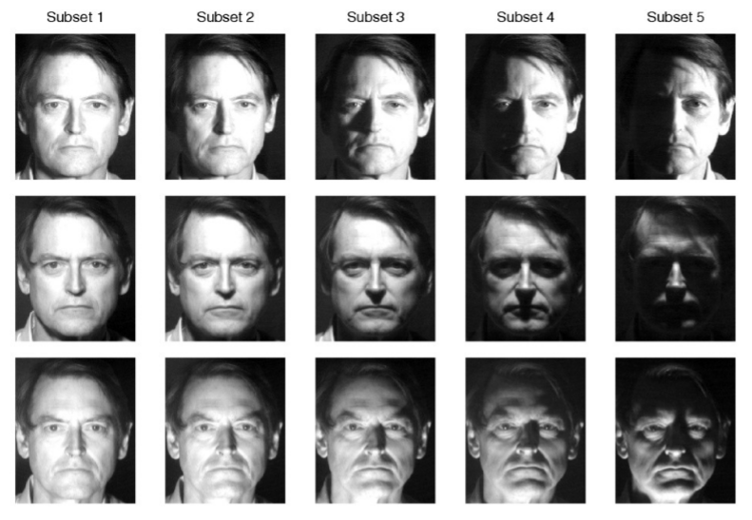

*Figure 2*: Face-patch changes under different illumination conditions. We can easily find how strong the illumination can affects the face appearance.

**2.) Eigenface Algorithm is susceptible to produces less accurate results compared to the input face image.**

The input face image is extracted by creating the feature vectors of maximum varied face points and computing Covariance column matrix using PCA. These faces are projected onto the face space that spans the significant variations in the face images stored in the database. These feature vectors are the eigenvectors of covariance matrix and having the face like appearance so that we call them eigenfaces. The eigenfaces where then computed and the one with the highest information of face images is the matched image.

The problem to this approach occurs when someone with one or more facial feature is likely similar to other registered images and the eigenface value of the recorded image is near to one of the eigenfaces stored in the database even if they are not the same person then it produces a result that states that the input is recognized as a registered face with the identity of the registered user.

Sample Result:

*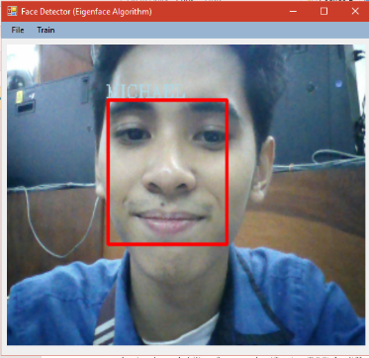Input*

*Expected Output*

*Actual Output*

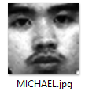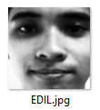

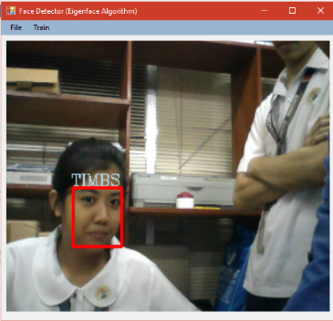

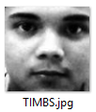

**3.) Inefficiency of PCA’s Dimension Reduction when total number of training faces (M) is larger to the squared of training face dimension (N*2*)**

The Principal Component Analysis’ dimension reduction starts at creating a *Lower Dimension Covariance Matrix* **(*C = ATA*)** which has the size of ***M x M***,where A is the matrix of the normalized face vectors and has a size of N*2* x M, as an alternative for the *Higher Dimension Covariance Matrix* **(*C = AAT*)** which has the size of ***N2 x N2***. However, when ***M*** is comparable to, or even larger to ***N2***, it would defeat the purpose of creating a more efficient means of comparing K best eigenfaces, where K is the number of eigenfaces that matched every face in the training space (K <= M).

**E. OBJECTIVES OF THE STUDY**

The objective of this research is to formulate a way to develop a Face Recognition Algorithm that is capable of learning and recognizing an individual faster, that is closer to how humans recognize faces. This research focuses on formulating a method of tracing missing people by means of Face Recognition System using Eigenface algorithm:

1. That can adapt to various lighting environment settings that will help the recognition to be more accurate and assure the identification of faces.
2. That will generate a more reliable output and provide the best matches of the inputted image.
3. That will maintain and offer a simple yet flexible integration in face recognition systems and sustain a low-level processing that will keep its efficiency.

**F. IMPORTANCE OF THE STUDY**

The face is an important part of who you are and how people identify you. It is arguably one of a person's most unique physical characteristics. While humans have the innate ability to recognize and distinguish different faces for millions of years, computers are just now catching up. Using traditional computer algorithms for face recognition is not enough to be considered near to natural face perception. But using the most advance technique in our technology today can possibly achieve a more efficient face recognition.

1. Face recognition requires no physical interaction on behalf of the user and it can lead to a faster biometric system.
2. Face recognition unlike other biometric systems is very affordable and continues to be a lot cheaper.
3. Using technology to aid in missing person can greatly increase the chance of finding and locating them.

**G. SIGNIFICANCE OF THE STUDY**

This study seeks to benefit the following groups of people:

1. To the ***programmers and developers,*** this study will encourage them to partake in the improvement of Face Recognition Algorithms and to advance and develop applications and system that uses this approach.
2. To ***government, organizations and community,*** it is estimated that 35,000 people are reported missing each year in Philippines. This equates to one person every 15 minutes. Using the proposed system can greatly help in locating each missing person.
3. To ***students***, that they will be more interested and encouraged to develop and innovate systems that would have a great social impact to our society. It can also educate and encourage them to explore other ways to implement today’s technology to a meaningful use.
4. Lastly, to the ***future researchers,*** that they will further enhance this study through investing more time in finding out the effectiveness and relevance and to what extent can Face Recognition help in today’s computing technologies. Also, to research for the latest and effective security methods and protocols that can be applied to the algorithm.

**H. SCOPE AND LIMITATIONS**

This study focuses on the Enhancement of Principal Component Analysis  
Based Face Recognition Using Eigenface Algorithm Applied in an Application for Tracing Missing People. Software, APIs and SDKs that will be used in the development of this project are either open-source or licensed technologies. Additionally, functions and features of this project only covers topic of Face Detection, Face Recognition, and Machine Learning, not topics related to Medicine, Engineering and other subject areas not mentioned or related above. The Software for this enhancement will only be an executable forms-based application, not a mobile application.

This study does not cover proprietary technologies and features of similar Face Recognition Systems and Face Recognition Software such as iPhoto (Apple), DeepFace (Facebook), Picasa (Google) etc. Any similarity among these systems within this study is not intended and may be incidental unless it’s open-source and available publicly.

**I. DEFINITION OF TERMS**

**Biometrics.**The measurement and analysis of unique physical characteristics especially as a means of verifying personal identity.

**Covariance Matrix.**A square matrix that contains the variances and covariances associated with several variables

**Eigenfaces.**The name given to a set of eigenvectors when they are used in the computer vision problem of human face recognition.

**Eigenface Algorithm.**A face recognition algorithm that gets the facial features in mathematical sense as an alternative to physical face feature by using mathematical transform for recognition.

**Eigenvalues.**A root of the characteristic equation of a matrix.

**Eigenvectors.**A nonzero vector that is mapped by a given linear transformation of a vector space onto a vector that is the product of a scalar multiplied by the original vector.

**Face Recognition.**An integral part of biometrics wherein facial features is examined and verified to match an existing person.

**Illumination.**An observable property and effect of light, may also refer to: Lighting, the use of light sources.

**Principal Component Analysis (P.C.A.).**A way of identifying patterns in data and expressing the data in such a way as to highlight their similarities and differences.

**Training.**The process of determining the value of weight and bias.

**Training Set.**Database of faces within the system.